|  |
| --- |
|  |
| **April/May Edition** |
|  |



# 

|  |
| --- |
|  |
| **STAFFING UPDATE: WELCOME**  We welcome our new Service Leader, **Amanda Braund**, who says: “I am really pleased and excited to permanently join the North Somerset Resource Service and I am looking forward to working with our Foster Carers going forward.”  Previous Service Leader **Brian Relph** says: “I would like to say a personal thank you to all of you, this has been a great authority to work for and I have been hugely impressed by the dedication of our highly committed Foster Carers. I wish you every success in the future.”  Welcome back to **Ewan Brooks** who has qualified as a CBT Therapist and will be spending 4 days a week in the Fostering Team and 1 day with CONSULT.  Welcome to **Tracy Twentyman** who will be the new Business Support Manager.  **STAFFING UPDATE: FAREWELL**  **Our very best wishes go out to:**  **Karen Cook**, our Business Support Manager who will be moving into a new role within the service  **Tazim Ladhu**, who will be taking up a management position outside NSC  **Alison Forde**, who will be starting an exciting new life in Canada |

If you would like to contribute to a Newsletter, please contact the Business Support team at the Resource Service. Tel: 01934 421900

|  |
| --- |
|  |
| Message from the Fostering Team Leader C:\Users\KMead\AppData\Local\Microsoft\Windows\Temporary Internet Files\Content.Outlook\NCTBM7GK\IMG_7102.JPGWelcome to the latest edition of your foster carer’s  Newsletter. I hope you all had a wonderful Easter  and are enjoying the slightly warmer weather.  Our Family Link Service have certainly been making the  most of the Spring approaching with our awards day at  **Court Farm**. This was a thoroughly enjoyable day and the farm  C:\Users\KMead\AppData\Local\Microsoft\Windows\Temporary Internet Files\Content.Outlook\NCTBM7GK\IMG_7104.JPGhave advised foster carers are welcome to visit ***‘free***  ***of charge’,*** meaning that you will only need to pay for  the children and any additional visitors. Just take your  new **NS foster carer ID badge** with you – see page 2!  Warm Regards  **Becky Norris, Fostering Team Leader** |
|  |
|  |

|  |  |  |
| --- | --- | --- |
| A massive congratulations to Iesha, one of our CLA, for her fabulous photography. Iesha’s GCSE Photography piece was entered into a competition entitled: “Community through the eyes of young people from all abilities” | **CONGRATULATIONS**  **Iesha’s**  **wonderful**  **photo**  C:\Users\ccripps\AppData\Local\Microsoft\Windows\Temporary Internet Files\Content.Outlook\2G71O3K1\Iesha picture community.png | The photograph came second, and will be displayed at The Norwegian Church Arts Centre in Cardiff Bay from 14th – 20th March  **Well Done Iesha!** |

**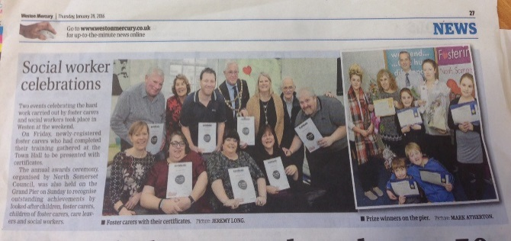In the Press**

* Did you spot our piece in The Mercury highlighting our celebrations of North Somerset Fostering?

**Check it out!**

* Check out our new Facebook Page to keep up-to-date with news and events!

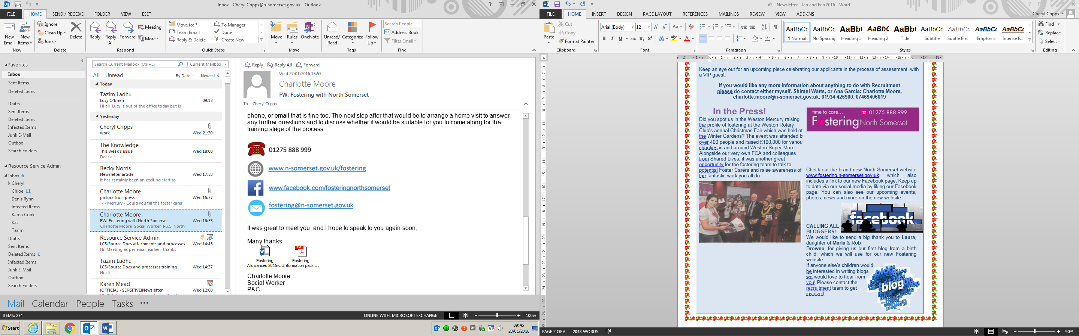

Charlotte’s Column

|  |
| --- |
|  |
| http://urbanleakz.net/wp-content/uploads/2014/02/bloggers-wanted.jpg  We are launching our **Blog Competition for both Looked After and Birth Children** of Foster Carers. This will be an opportunity for the children and young people to share some their views and stories, with a chance to win some fantastic prizes from  **Puxton Park** and **AirHop**!  **Deadline** is 15 April, at the end of the school holidays, and there are two categories for 0-10 and 11+.  **☺ Happy Blogging! ☺** |

|  |  |  |
| --- | --- | --- |
| Spring is here, and we have some exciting recruitment news! **Our new fostering video is due to be released, starring some of our fantastic Foster Carers and children.** This will be a great resource for recruitment events – keep an eye out for this on our website! We have also been working with Chief Executive of the Council, Mike Jackson, who is supporting the fostering team by helping make links with local businesses and helping us to effectively promote fostering within the Council. | | B:\HSS\Resource Service\FOSTERING SUPPORT TEAM\PHOTOS\Awards day 2016\A- General pics\IMG_1766.jpg  B:\HSS\Resource Service\FOSTERING SUPPORT TEAM\PHOTOS\Awards day 2016\A- General pics\IMG_1746.jpg |
| B:\HSS\Resource Service\FOSTERING SUPPORT TEAM\PHOTOS\Awards day 2016\A- General pics\IMG_1871.jpg | **Fostering fortnight is the 16th – 19th May** and we are pleased and excited to launch our Heart FM radio campaign. Listen out for us! Don’t forget to refer a friend with an incentive of £300! | |

***\*\* Dates for your Diary \*\* Dates for your Diary \*\****

|  |
| --- |
|  |
| **Greetings Cards**  A 13 year old young man placed with North Somerset Foster Carers wrote a heartfelt letter to Clinton Cards urging them to design a card for the near 70,000 UK children in care, to send to their Foster Carers on Mothers’/Fathers’ Day. Clinton Cards responded by instructing their card-buying department to speak with the supplier in order to investigate the possibility. This inspiring letter will hopefully encourage others to share their views and aim high –  anything is possible! Kid’s Corner! **Weird but True!!**  The earth is slightly pear shaped  Most people blink more than 14,000 time a day  Elephant calves suck on their trunks just as human babies suck on their thumbs  Some people taste-test pet food for  a living  **BRAIN TEASER…**  What is so fragile that when you say its name, you break it? |
|  |

**9 May:** Hospital Stand at Weston General Hospital at 11:00 – 12:00

**19 May:** Information Evening at Ashcombe Primary School at 18:30 – 21:00

***For more details, please contact Charlotte:***

[**charlotte.moore@n-somerset.gov.uk**](mailto:charlotte.moore@n-somerset.gov.uk)**, 01934 426900, 07469 406019**

|  |
| --- |
|  |
| Foster Carer News **ID Badges -** are now available for Foster Carers! They will be issued via the Fostering team and will include the photo you submit as part of your Foster Carer Profile (see below). Those who have already completed their profile will receive their ID badge shortly!  **Foster Carer Profiles -** Foster carers all need to complete a profile of their family. This needs to be updated at your review and is invaluable when used with children. If you haven’t already done yours we are offering sessions to help. Your SSW will have details!  **Egress Secure Email -** We are always looking for ways to improve our communication with Foster Carers. We are therefore pleased to inform you that North Somerset has now launched our Egress secure email portal. Egress is simple to use and allows us to send you confidential information securely and vice versa using your home email address. You should have received an email telling you how to use Egress, (with our user guide attached). However if you have any issues please discuss this with your Supervising Social Worker.  ***Reminder for Foster Carers:***As always you have a responsibility to ensure that any confidential information or information relating to children and young people must be stored securely. Confidential information, secure emails or any attachments that have been sent via Egress MUST not be saved to your home PC as this is not a secure system. Thank you. |
|  |

|  |
| --- |
|  |
| TRAINING UPDATE Dawn Williams  Business Partner to Fostering and Adoption -  Learning and Development Team  As Spring approaches and the wonderful season of new beginnings arrives it feels timely to update you on training issues. Dawn Williams is now part of the new Corporate Learning & Development Service. Dawn works on Monday, Tuesday & alternate Wednesdays and her numbers remain the same: 01275 888976, Mobile number: 07766366114   |  |  |  | | --- | --- | --- | | We have now completed a review of the mandatory training required for progression. There is an updated template available on line or via your Supervising Social Worker. You will be able to map your own training requirements/attendance enabling your SSW to go through this with you as part of our annual review and identify further training needs |  | We are very pleased to inform you that we have agreement to purchase an on-line level 3 course via KCA (Kate Cairns Associates) ‘Working with Traumatized Children certificate’. This will enable Carers who complete the certificate to evidence their ability to be considered as Advanced Level Carers. There will be an application process in place for Carers to show their interest in pursuing this new provision, so please do get in touch with Dawn and/or speak to your SSW | |
|  |
|  |

|  |  |  |
| --- | --- | --- |
| **SUPPORT GROUPS**  From February this year fostering support groups are available via CPD on-line. As always, you are welcome to attend any of our support groups on the day and this will be credited to your CPD record. Prior booking is advised but not required. Support Groups are a fantastic opportunity to meet other carers, share experiences and get advice from specialist workers. You are welcome to come to one or more. **See you there!**  We are in the process of reviewing each support group, looking at attendance, frequency and whether they meet your needs as carers. We welcome your feedback. If you have any comments or suggestions please contact: [susannah.weeks@n-somerset.gov.uk](mailto:susannah.weeks@n-somerset.gov.uk)  Please book your place at support groups via CPD on-line or tell your SSW.  **DETAILS OF NEXT SUPPORT GROUPS:**  **Stay and Play for Carers of Under 5s**  **Friday, 8 April @ Ashcombe Children’s Centre BS22 3NA 1.00-2.30pm.**  Older children and Carers’ own children are welcome as it is school holidays – activities, singing and fun! | **Information, advice and support from other Carers and Specialist Staff** | **Adolescent Support Group**  **22 April 9.30 for refreshments. Session: 10.00-11.00am @ Castlebatch Children’s Centre, BS22 7PQ**  Topic-based NEW support group providing support for Carers dealing with the challenges of looking after teenagers. Developed from recent ‘Adolescents are People Too’ course, but open to all. Will run on 4th Friday of alternate months.  **SAFE Group**  **Wed 11 May 12.30-2pm @ The Firs, Drove Rd BS23 3NX.**  For Carers of children with additional needs. Topics: Direct payments and Summer Activities for your Children.  **Approval and Beyond**  **Tuesday, 6 April at 6.30-8pm @ The Firs, Drove Rd BS23 3NX.**  For people who have completed Skills to Foster and our recently approved NS Carers. Coffee, cake and chat included.  **Ambassadors Group**  Our Foster Carers are experts on local knowledge and creative thinking for appealing to potential Carers. We hold regular meetings with Foster Carers to discuss recruitment targets and make plans. If interested, please let us know, and join us for the next meeting: **9 June at 9.30–10.30 at The Town Hall.** |

|  |
| --- |
|  |
| **USEFUL CONTACTS**  **Resource Service including the Fostering Team**: 01934 421900  **Emergency Duty Team (out of office hours):** 01454 615165  **NSFCA:** 07784 937981  **CONSULT:** 01934 421956  **Children’s Services:** Single Point of Access to contact social work teams: 01275 888808  **Dawn Williams (Training):** 01275 888976 Mobile: 07766366114 (Mon, Tues and alternate Wed)  [www.fostering.n-somerset.gov.uk](http://www.fostering.n-somerset.gov.uk)  Email: [fostering@n-somerset.gov.uk](mailto:fostering@n-somerset.gov.uk)  As a Foster Carer you can now register on our Fostering Website as a member and access relevant up-to-date information. Please go and sign up for free!  **North Somerset On-Line**  **Directory of Services:**  Details of services and activities  for children and families across North Somerset  www.n-somerset.gov.uk/fis  <https://www.fostering.net/>  **EVENTS IN YOUR AREA**  **Weston Street Art Trail**  To see the Art Festival map, go to [www.visit-westonsupermare.com](http://www.visit-westonsupermare.com) and search for ‘Weston street art trail’  **Weston Air Show 18-19 June**  **Beach Lawns, Weston-super-Mare** |

|  |
| --- |
|  |
| North Somerset Foster Carer Association **Message from the Chair – Jackie Bush**  At February half term, the Committee and 35 children set off in 10 taxis for **Court Farm in Banwell**. As well as the usual attractions there were lots of new born chicks, lambs and calves, and the Farmer, Peter, gave us a demonstration of milking. There was a show with the characters from ‘Frozen’ and a lovely buffet – all kindly donated by the taxi drivers from Weston. All the children behaved beautifully; children and adults went home happy, full and tired.  **Coffee Mornings** are every other month; 10.00-12.00 at Weston Cricket Club and we would really like as many Foster Carers as possible to attend. There is always a raffle (donations of prizes welcome!) and usually meetings include a guest speaker. Dates to be circulated following our AGM (see below)  **Our Annual General Meeting** is on 5 April at **Gigglz Fun House** in Clevedon at 6pm. Everyone welcome, bring along the children who can play for free. **Nominations are invited** for the Committee, especially for the positions of Chair, Secretary and Treasurer, as the current Officers have been in place since NSFCA was set up. The new Committee will make plans for outings, activities and coffee mornings in the coming year. NSFCA have already committed to providing tombola and information stalls at fostering recruitment events in the Summer. Any queries about NSFCA please contact **Jackie Bush** |
|  |



|  |
| --- |
|  |
| C:\Users\KMead\AppData\Local\Microsoft\Windows\Temporary Internet Files\Content.Outlook\NCTBM7GK\IMG_7101 (002).JPG  **Family Link** Fun on the Farmfor Family Link **Family Link Awards Day at Court Farm!**  ***Family Link – Providing short breaks for disabled children***  For those who came to celebrate the awards day, it was a great day and fantastic to see the children enjoying themselves. Despite the cold, fun was had by all, feeding the lambs and milking the cows and meeting other Carers.  We would like to say a huge thank you to all our family link Carers for all the work you do!! \_\_\_\_\_\_\_\_\_\_\_\_\_\_\_\_\_\_\_\_\_\_\_\_\_\_\_\_\_\_\_\_\_\_\_\_\_\_\_\_\_\_\_\_\_\_\_\_\_\_\_\_\_\_\_\_\_\_\_\_\_\_\_\_ Finance Issues **Pocket Money Queries**  Some Carers are wondering about levels of pocket and Birthday/Christmas gift money. Under the 2015 finance policy there are no set levels of pocket money/gift money - just like our own families, each of us give different amounts of money, affected by what we give our own children and what their peers might be getting! All children must receive their own pocket money as it teaches them budgeting skills, the value of money and allows them to make their own choices. This is separate to the money spent on them for activities and personal items. Discuss this with your Supervising Social Worker or the Child Care Social Worker if you still have any queries |
|  |