**Message from the Team Leader**

It has been an exciting summer for the fostering service and our involvement in local activities and events has really paid off, raising the profile of fostering and generating lots of interest from people thinking of becoming a foster carer. On the 10th October we will be moving to our new offices in the Town Hall and it was lovely to see so many of you come and help us bid a fond farewell to Clifton Road at our summer barbeque.  With the sun shining a good time was had by all and I would like to thank everyone who contributed to making the day such a success.  October is Sons and Daughters Month!! Sons and daughters month is part of the Fostering Networks annual campaign to celebrate the fostering family.  Here in North Somerset we would like to say a huge thank you to all those sons and daughters of foster carers for the vital contribution you have made to fostering.  In this edition you can find details of what our Caring Crusaders group will be doing to celebrate Sons and Daughter’s month with a spooky Halloween theme and lots, lots more!! We hope you enjoy.

***“Fun in the sun as we prepare to leave Clifton Road…”***

**.**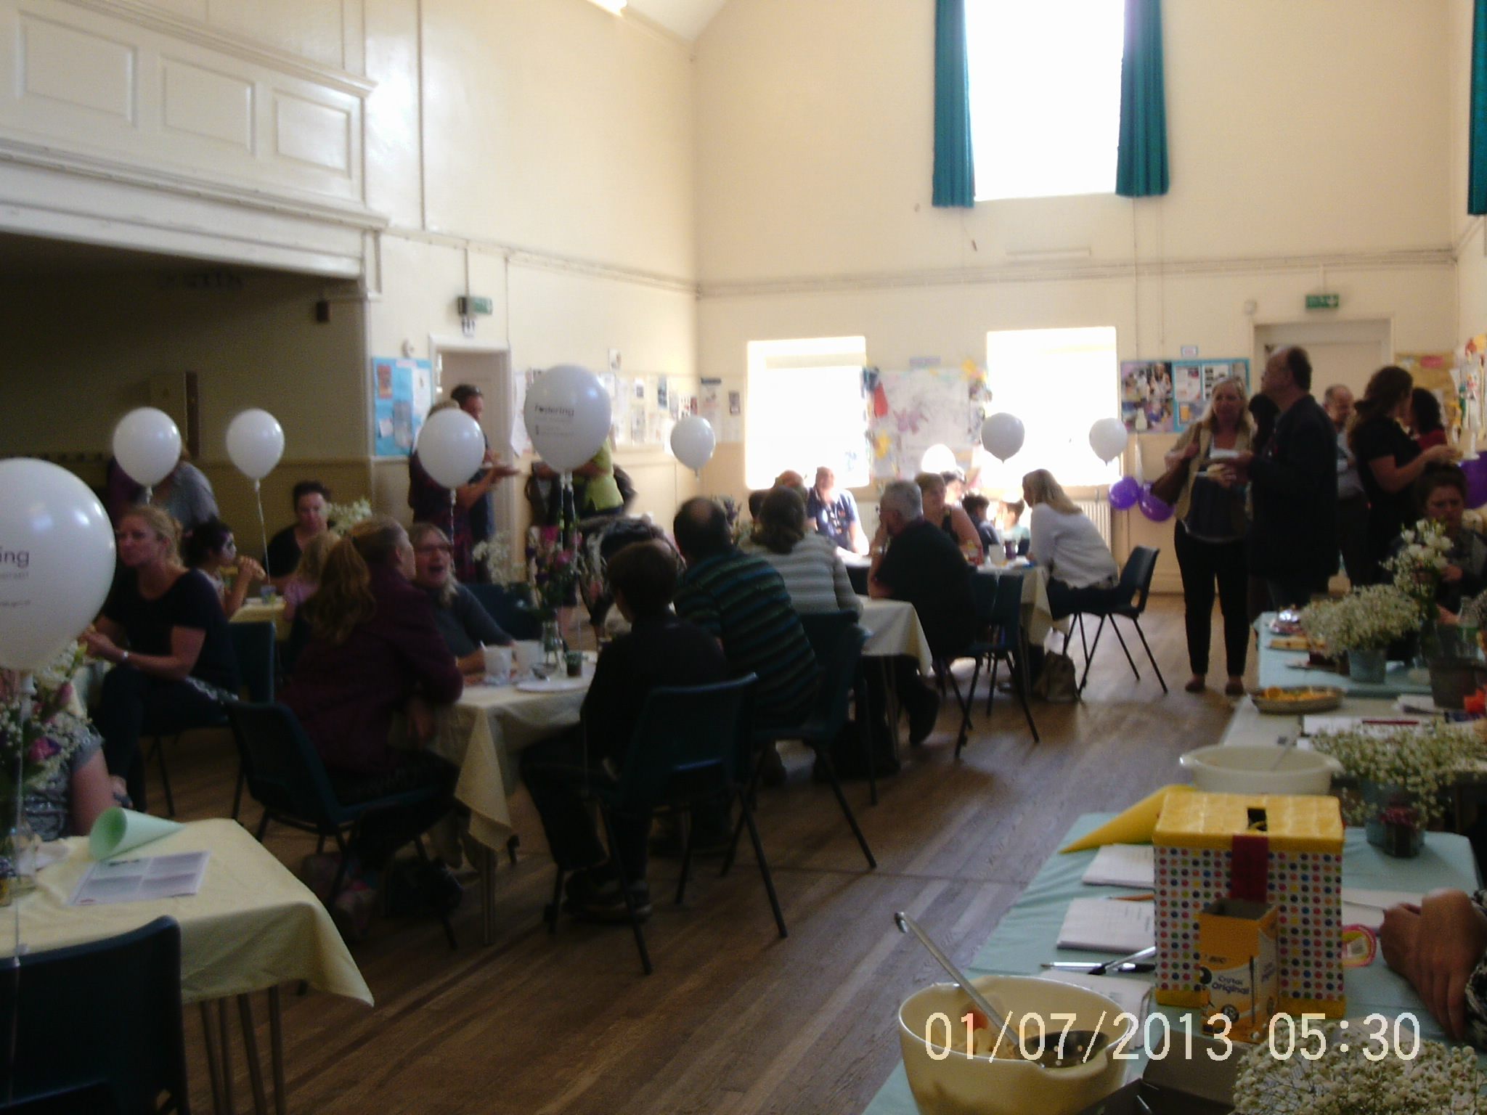

**Support Groups**

**Carers of teenagers**– for all carers approved for ages 12+. Next group 22 October 2015, 1 – 2.45pm at South West Skills Campus (Weston College) in Locking Road, WSM. BS22 8NL. Topic: Education Issues including visit to Construction and Engineering Centre of Excellence.

**Contact:** [**cornelia.kurz@n-somerset.gov.uk**](mailto:cornelia.kurz@n-somerset.gov.uk)

**Stay and Play for Carers of Under 5’s** – for carers approved for younger children. Includes activities, messy play and singing. Meets 2nd Friday of the month, 1-2.30pm at Ashcombe Children’s Centre, Stepping Stone Walk, Earlham Grove. WSM.

**Contact:** [**debbie.stephens@n-somerset.gov.uk**](mailto:debbie.stephens@n-somerset.gov.uk)

**Caring Crusaders** - for sons and daughters of foster carers (under 16 yrs). Activities, refreshments and support to children who share their families with other children during school holidays. Next group: 28 October 2015 at Ashcombe Children’s centre, Stepping Stone walk, WSM.

**Contact:** [**helen.stock@n-somerset.gov.uk**](mailto:helen.stock@n-somerset.gov.uk)

**Adoption Support –** for carers supporting children during the transition to adoption. Crèche available. Next groups: 3rd November 2015, 5th January 2016 and 1st March 2016, 10-11.30am at The Firs, Drove Rd, WSM. BS23 3NX

**Contact:** [**melissa.fowler@n-somerset.gov.uk**](mailto:melissa.fowler@n-somerset.gov.uk)

**SAFE – support group for carers looking after children with additional needs.** Includes bring and share lunch; and the group has its own secret Facebook group for sharing support and information. Next group 11th November 2015 at The Firs, Drove Rd, WSM BS23 3NX, 12.30-2pm. Topic: Emotional well-being.

**Contact:** [**susannah.weeks@n-somerset.gov.uk**](mailto:susannah.weeks@n-somerset.gov.uk)

**Recently Approved Carers Group –** for any carer who has been approved for less than 2 years. Induction, support to get training and development standards completed, meet other carers and eat cake (optional)! Next groups 20th October 2015 and 8th December 2015 at The Firs, Drove Rd, WSM BS23 3NX at 7pm.

**Contact:** [**charlotte.moore@n-somerset.gov.uk**](mailto:charlotte.moore@n-somerset.gov.uk)

Please think about joining a group – both for what you can receive, and also how you can support and encourage other carers!

.

**Foster Carer News**

**Welcome to New Carers:** We would like to welcome our newly approved foster carers to North Somerset, Kay Lewis, Marie and Richard Downes, Derek and Paula Williams and Stephen Fiest have recently been approved at panel. We look forward to working with all of you.

**NSFCA:** Coffee and cakes were enjoyed by all at our last NSFCA coffee morning.

Profits were donated to Macmillan Cancer Research. Our next coffee morning will be held on Wednesday 11th November 2015 at Weston-super-Mare Cricket Club and we look forward to seeing you there.

**Dates for your diary**

Children’s Christmas Party – 5th December 2015

Foster Carer’s Christmas lunch at Woolpack, St Georges – 15th December 2015. More information to follow….

**Ambassador group:** Thank you to those carers who attended the last ambassador group. It was a great opportunity to share the update on how our recruitment is going, and discuss together what events and ideas are going to work best for future recruitment. If you would like to join the next ambassador meeting please do let us know, the meeting will be held at our new location (Town Hall) on 8th December 2015, 9.00 -10.00.

**Training**

**Upcoming Courses**

-Inter-Agency Child Protection-Introduction: 6th  and 8th October

-Pediatric First Aid: 6th, 7th, 13th and 14th October then 14th and 21st October

-Child Protection-Basic Awareness for Foster Carers/Refresher Training: 7th October

-Moving Children on - 15th October

-Mental Health First Aid: 2nd and 9th November

-The Early Language Development Programme: 6th November

***For further details, please speak with your supervising social worker.***

**Newsletter – October/November 2015**





**Charlotte’s Column**

**Recruitment Events**

A massive thank you to all who have come along to our events. We have had a great summer, and with your help we have been able to raise the profile of North Somerset Fostering, and increase our enquiries from potential carers. Once again, it was so valuable to have you as carers attend and support these events with us. We continue to get feedback from potential foster carers that you are the people they want to speak to. Having foster carers and their families at events gives people who are interested in fostering an opportunity to speak to those who have already been through the assessment process, and who know the reality of bringing fostering into their family.

Please do have a look at the events below and see if there are any that you and your family could come along to. You do not have to attend a full day, just a couple of hours speaking to potential carers would be really helpful. Don’t worry if you have not attended an event before, there will be fostering staff overseeing the event all day and we have a briefing sheet to help guide your discussions. There will be merchandise to give away, a newly designed fostering T-shirt to wear, and plenty of fun to be had!

Please contact Charlotte, Shirani or your supervising social worker, if you would like further information or can help out ant any of the events below.

**- Thursday 1st October – Information evening at Ashcombe Primary: 18.30 – 21.00pm**

**- Tuesday 13th October – Weston Hospital, Rafters canteen: 10.00 – 14.00**

**- Saturday 31st October – Halloween Fright Night in town square**

**- Early November (date TBC) – Weston Christmas Lights switch on**

**- Friday 13th November – WSM Carnival: 19.15**

**- Saturday 14th November – WSM Christmas Lights Switch on**

**- Saturday 21st November – Craft Market, Nailsea**

**- Saturday 28th November – Christmas Fayre at Winter Gardens (alongside the FCA)**

*Clear skies at the balloon fiesta Powerful support for North Somerset Fostering*

*Sun Shining and ready to spread the Look familiar? Our Family Link fan found word about fostering! us at this event!*

\\nsc-gov\UserProfiles\Redir\kowen\Desktop\Connie and power rangers (00000002).jpg

\\nsc-gov\UserProfiles\Redir\kowen\Desktop\balloons.tif

\\nsc-gov\UserProfiles\Redir\kowen\Desktop\Family Link (00000002).JPG

\\nsc-gov\UserProfiles\Redir\kowen\Desktop\Balloon stand (00000002).jpg

**News from the Fostering Service**

**Save the Date to Celebrate!**

The next Annual Awards Ceremony will be taking place 24th January 2016 and is sure to be a fantastic event.

Further details to follow but make sure this date is in your diary.

We look forward to seeing you there!!!



**Staffing Update**

We have recently welcomed

John Lewindon and Shirani Watts (Supervising Social Workers) to the Fostering Team and Karen Morgan (Leaving Care PA). We wish them all the best in their future with North Somerset Council.

Tess Price (Supervising Social Worker) is officially on maternity leave and we wish her all the best for her exciting future.

**Dismaland!**

Hopefully quite a few of you managed to go to this big event which transformed the Tropicana and put Weston on the map? Banksy wanted a theme-park with a theme – and it certainly made me think as I wandered around the exhibition of art, installations and fairground! A huge thank you goes out to the event organiser’s who generously donated the Local Authority some free tickets that many of our care leavers and older looked after children were able to enjoy.

*‘****Susannah meets the seagulls at Dismaland’***



**We are Moving!**

As from Monday 12th October the Resource Service will be based in the Old Town Hall, Weston super Mare. If you are coming for a meeting, please use the entrance in Oxford Street. The telephone number will be the same: 01934 421900

**Caring Crusaders (Sons & Daughters)**

A great time was had by all at the recent Caring Crusaders Group. The event took place at Noah’s Ark Zoo Farm. The weather was lovely and the day was a great success. The next Caring Crusaders event will be a spooky Halloween themed afternoon taking place on the 28th October 2015. The focus will be on emotional support with some pumpkin carving for a bit of fun! Please speak to Helen or Mel for further details.



**Care Leaver of the Month**

Do you know a care leaver who has excelled in their transition to adulthood, overcome adversity, gone the extra mile or is just a shining example for others to follow in the footsteps of?

Well from 1st September, we are launching the Care Leaver of the Month Award. Anyone can nominate a care leaver they feel deserves an award and we will pick one each month through a multi-agency panel to be Care Leaver of that month. They will receive a letter of congratulations from the Director of People and Communities as well as a £30 high street voucher.

It’s all about distance travelled, not necessarily top marks or getting it right first time. So come on, nominate a care leaver that you know has done something extraordinary!

Nomination forms are available from: Business Support (01934 421900) or [Katie.warren@n-somerset.gov.uk](mailto:Katie.warren@n-somerset.gov.uk). Forms should be returned by the end of each **month.**

**Events in your area**

**Halloween Fright Night**

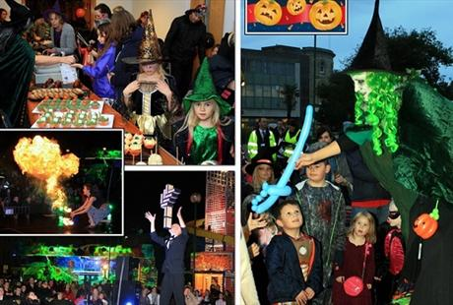

There will be Halloween fun for everyone in Weston-super-Mare town centre on Saturday 31st October at the free Halloween Fright Night Event! More details can be found in the following link:

<http://www.visit-westonsupermare.com/events/halloween-fright-night-p1603193>

*Superheroes Weekend!*

**

17th and 18th October at Puxton Park

More details can be found in the following link:

<http://www.puxton.co.uk/events>

**Fostering Network**

Hopefully you are all getting your Fostering Network magazine ‘Foster Care’? The Winter edition includes articles about caring for teenagers ‘Teen Troubles’ and another on the importance of foster carers encouraging children to do well in their education ‘An Ambassador for Education’. Do read them!

Check out the Fostering Network website for info about how to register for tax and National Insurance: put this into your internet browser [**https://www.fostering.net/all-about-fostering/foster-carers/finances/income-tax#.Vflb5xFViko**](https://www.fostering.net/all-about-fostering/foster-carers/finances/income-tax#.Vflb5xFViko) **I**t is important that all foster carers are registered as self-employed, even though many carers do not receive enough income to make them start paying tax.

**Children in Care Council**

**Upcoming dates**: Unite (Care Leavers) October 28th 2015, November 25th 2015 and December 16th 2015.

Ambitious Voice (CICC) October 26th 2015, November 23rd 2015 and December 14th 2015.

Mars Bar Cake



3 Mars Bars

75g margarine

3 tbsps golden syrup

225 rice crispies

1 large bar plain chocolate

1) Cut the Mars Bars in to small pieces.

2) In a pan, melt the Mars Bars with the margarine and syrup.

3) Put Rice Krispies in a bowl and add the melted mixture slowly. Mix well.

4) Press the mixture flat in to a baking tray and leave to cool.

5) Melt the chocolate and spread over the top. Leave to set.

**Kids Corner**

**Just Having a Laugh!**



**Why do bicycles fall over?**

Because they are too tired!

**Why do dragons sleep during the day?**

Because they fight knights!

**Why was the broom late?**

It over swept!

**Why couldn’t the pirate play cards?**

Because he was sat on the deck!

**Refresh Yourself!**

We would like to invite Kinship Foster Carers and Special Guardian Carers to:

**Coffee/Tea and Learn Carers Support Sessions**



**Yourself and your knowledge**

**12 noon until 1.30pm**

**At the** **Vintage Community Church**

**25 Hughenden Road, Weston-super-Mare, BS23 2UR**

* 22nd Sept 2015 Sheila Harding, CLA Nurse will talk about Health
* 24th Nov 2015 Dawn Williams, Training Officer – Decorating Cup Cakes
* 26th Jan 2016 Ceri McSweeney, Social Work Assistant will talk about Life Story Work

This is an opportunity to meet with members of the Kinship Team as well as other kinship carers within North Somerset. Additionally, we would also like to take the opportunity to provide you with information about the services, training and support available to you.

All are welcome, there is also a small play area for children under 5 but they will require adult supervision.

We look forward to seeing you and would also value your input on how you may like to develop these sessions.

**Reminder!** We will be sending out SDQ questionnaires in October. Please ensure you complete and return to Chloe Manuel at: Town Hall, Post Point 20, Walliscote Grove Road, WsM, BS22 1UJ

**Useful Contacts**

**Resource Service:** 01934 421900

**EDT:** 01454 615165

**NS Foster Carers Association:** 07784 937981

**North Somerset Council:** 01275 888888

**Consult:** 01934 421956

**Fostering Network:**

[**https://www.fostering.net/**](https://www.fostering.net/)

**NS Fostering Website:**

[**http://fostering.n-somerset.gov.uk/fm/**](http://fostering.n-somerset.gov.uk/fm/)

**Refer a friend and gain £300**

Did you know that North Somerset run a ‘Refer a Friend’ scheme for our foster carers?Every foster carer who refers a friend that is approved as a carer will receive the ‘Refer a friend’ incentive of £300. If you know someone who may be interested – don’t delay! Contact us through the website, or call us for an informal chat: **01275 888 999,** or **fostering.n-somerset.gov.uk**

Anagrams

Below are the answers to the anagrams posted in the last edition of our newsletter. They weren’t easy so have a look to see how you got on! ☺

1) G P I - ***PIG***

2) Y K E O N M- ***MONKEY***

3) E K S N A- ***SNAKE***

4) F F E A R G I - ***GIRAFFE***

5) T C A - ***CAT***

6) T B I B A R - ***RABBIT***

7) G D O - ***DOG***

8) P H T A N E E L - ***ELEPHANT***

9) W C O - ***COW***

10) T G A O - ***GOAT***

